* 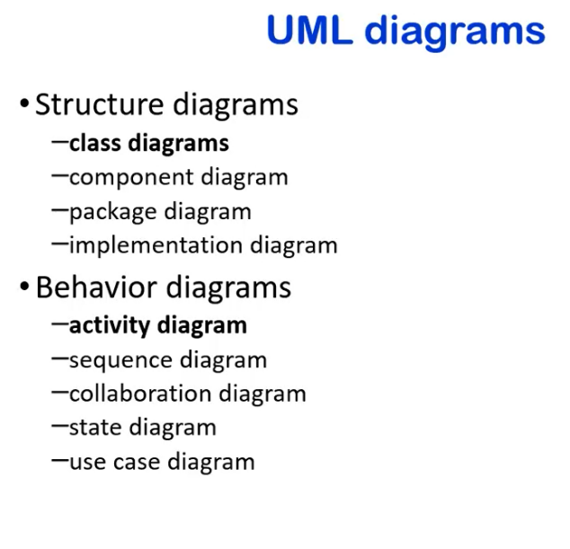

* 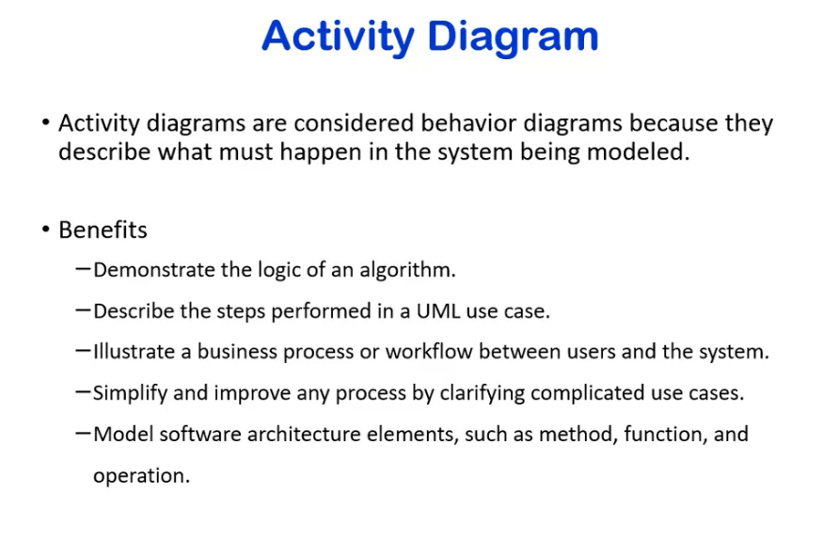
* Model is how the user interacts with the system
  + shows business process
* primary goal: improve understanding of any process
* used to model different elements
  + functions
  + operations
  + tasks
* simplest diagrams
* few notations

|  |  |
| --- | --- |
| 1 - action: | a step in the ctivity wherin the users or software perform a given task. Actions are symbolized with round-edge rectangles |
| 2 - decision node: | a conditional branch in the flow that is represented by a diamond. It includes a single input and two or more outputs. |
| 3 - control flow: | Another name for the connectors that show the flow between steps in the diagram. - shows action between two steps   * + - arrow is used |
| 4 - start node | * + - * symbolizes the beginning of the activity. The start node is is represented by a black circle |
| 5 - end node | * + - * represents the final step in the activity. The end node is represented by an outlined black circle. |
|  |  |

* 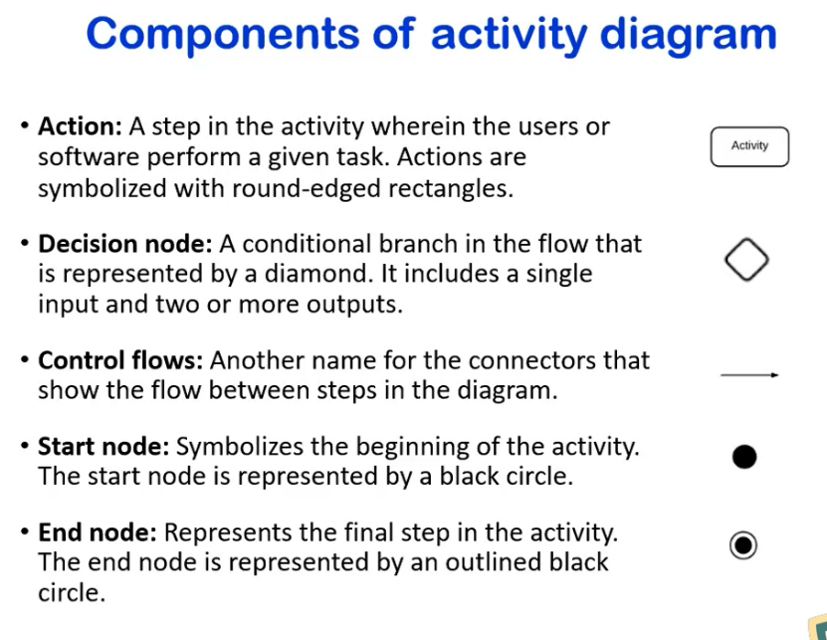

* 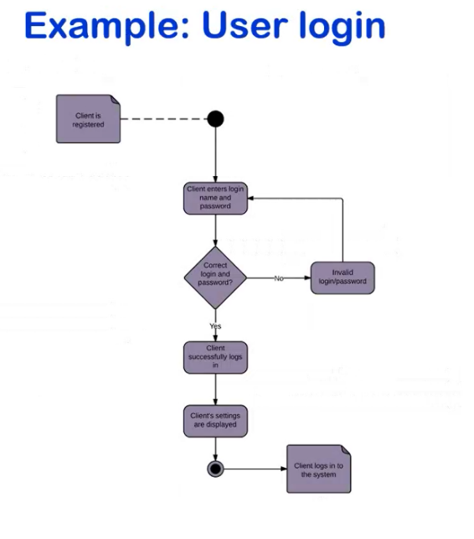

* 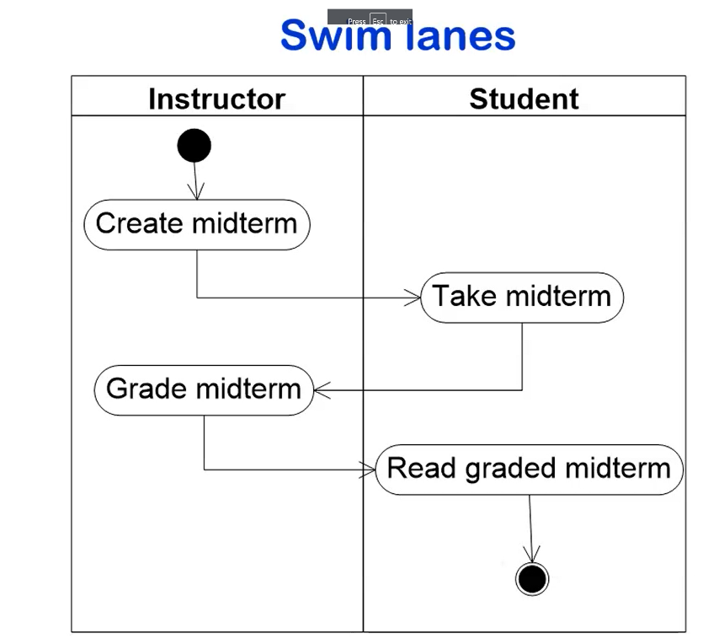

* 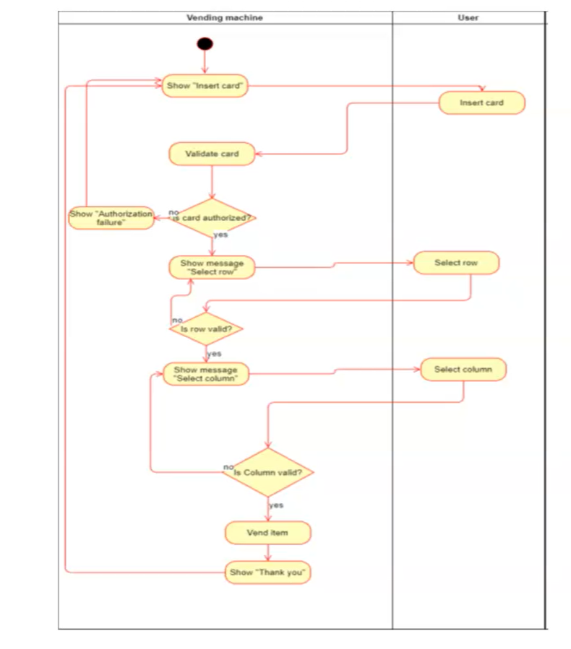

* 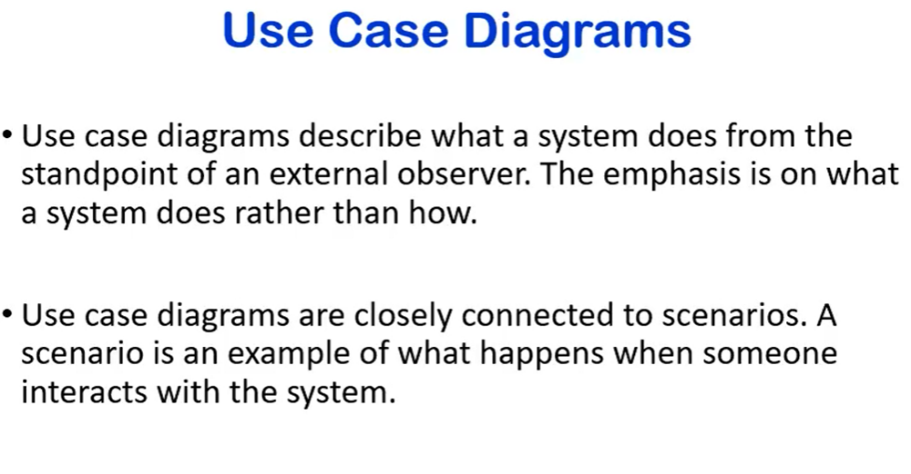

* 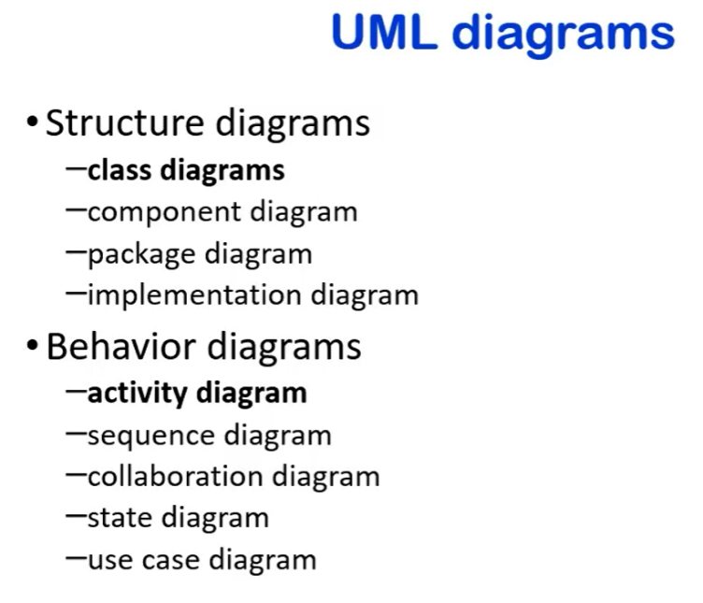

* 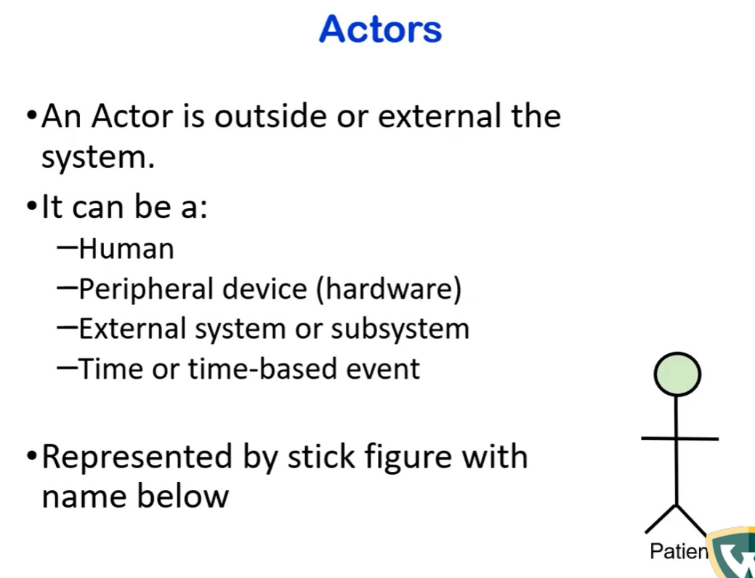

* 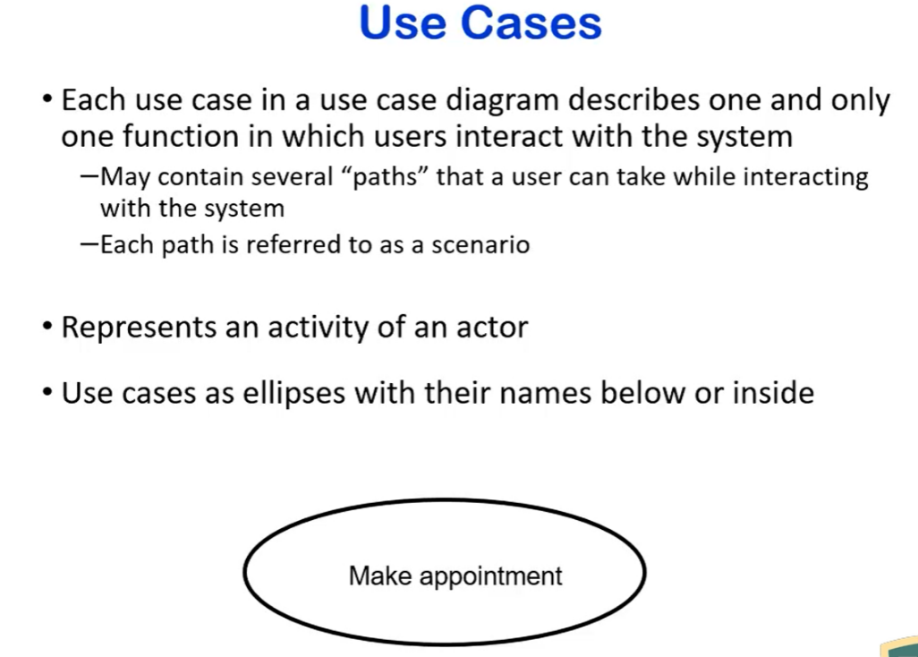

* 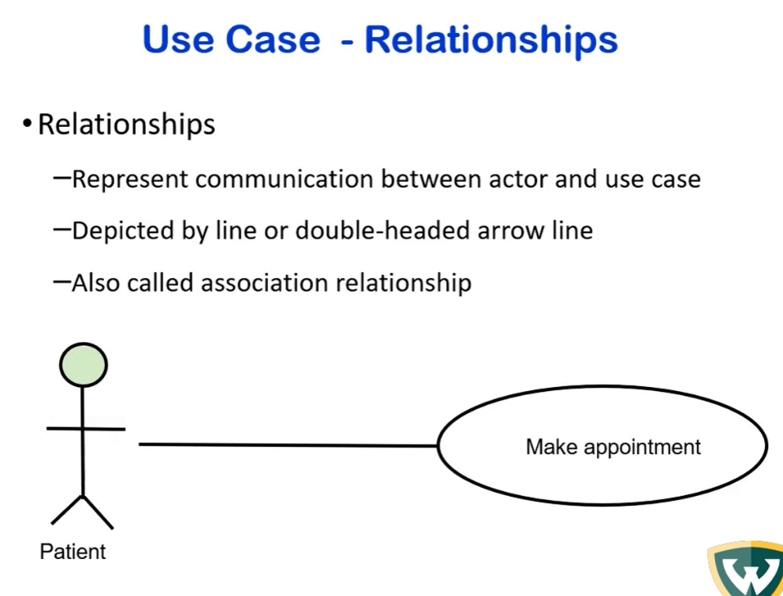

* 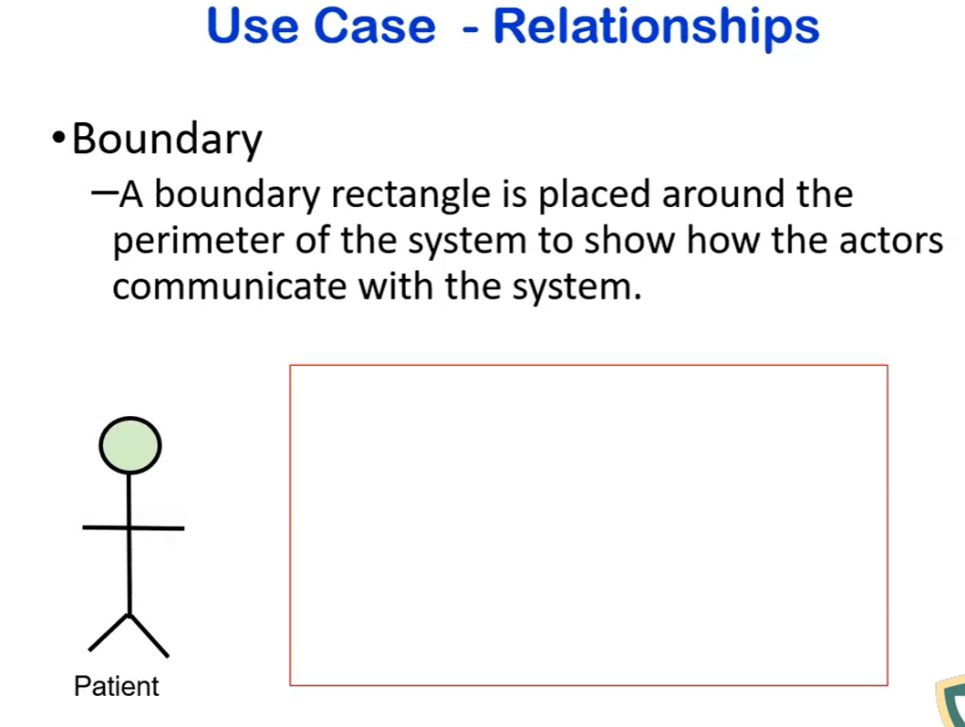
  + this is a boundary of what we will be implementing
* 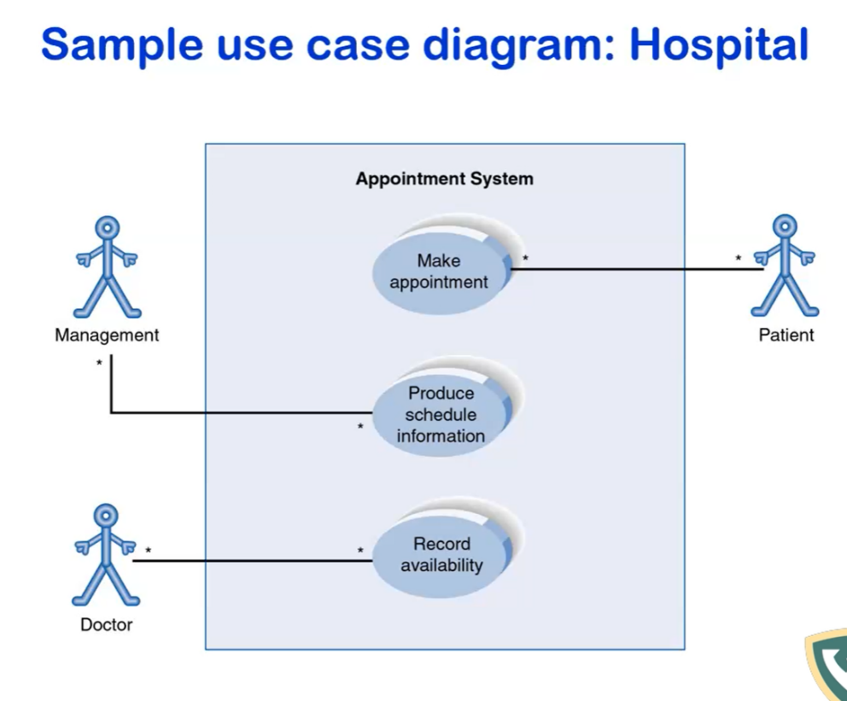
  + 3 users using the system
  + shows which functionalities are available to each
* Improve Software Management system
  + 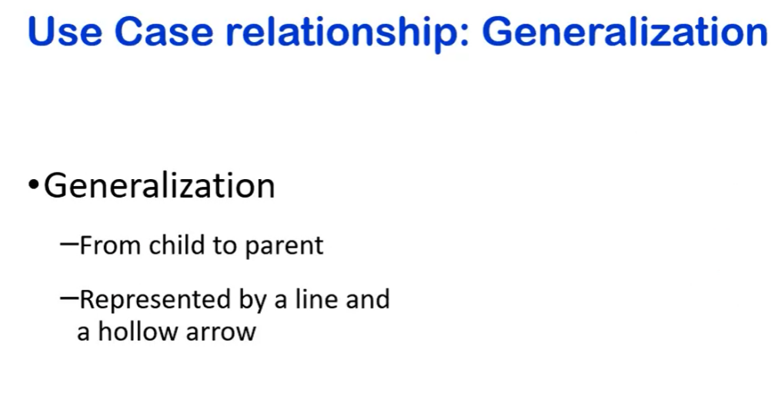

* 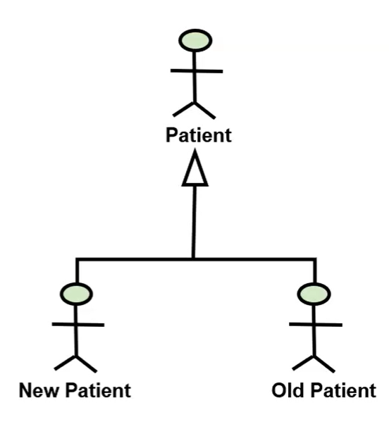

* 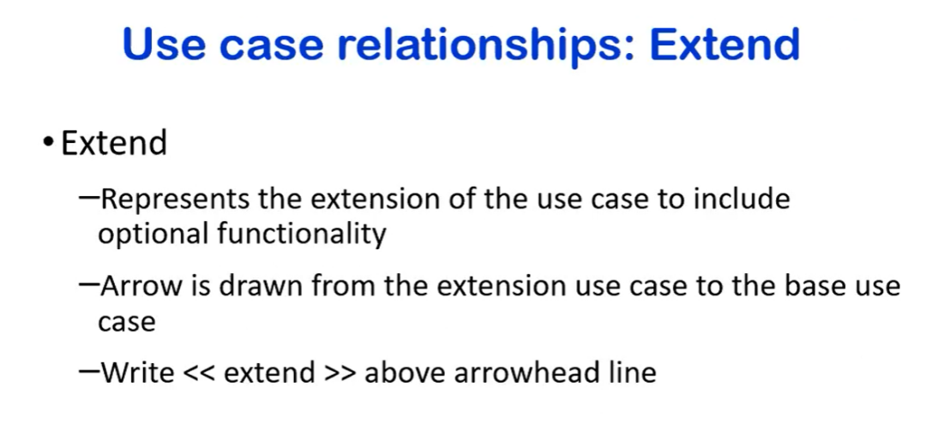
  + represents extension of a use case for optional functionality
  + 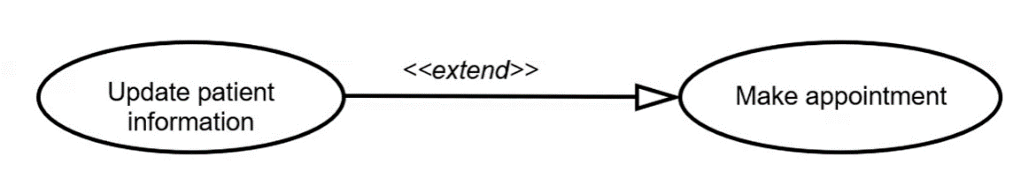

* 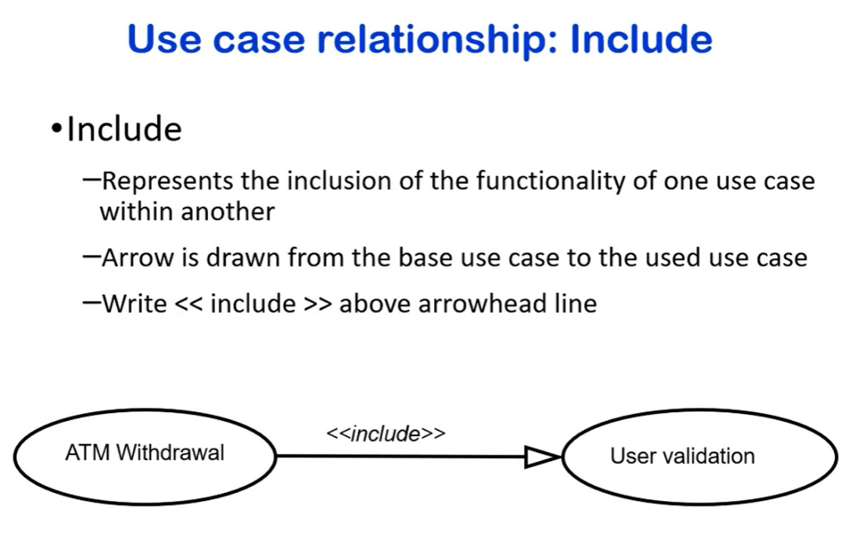
  + a mandatory functionality
* 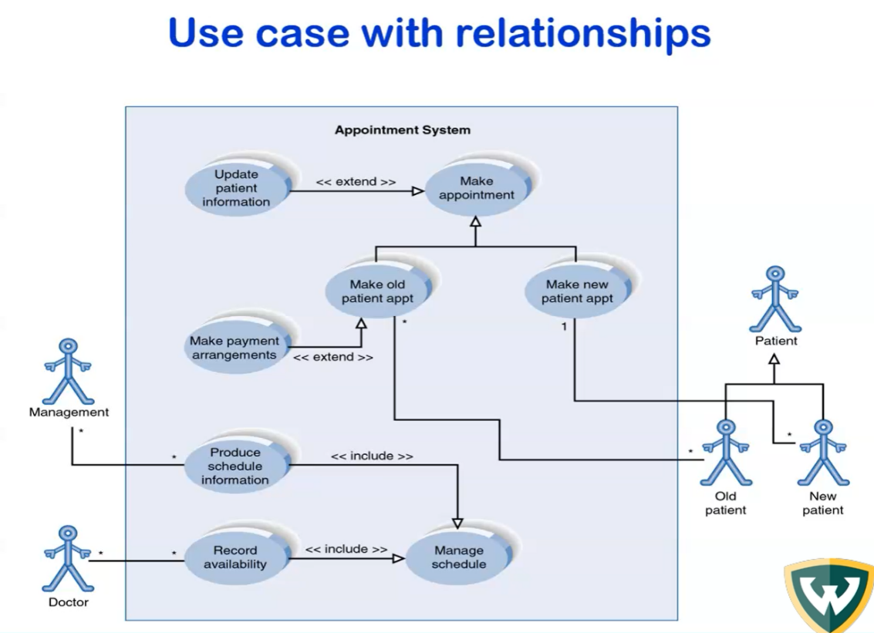

* 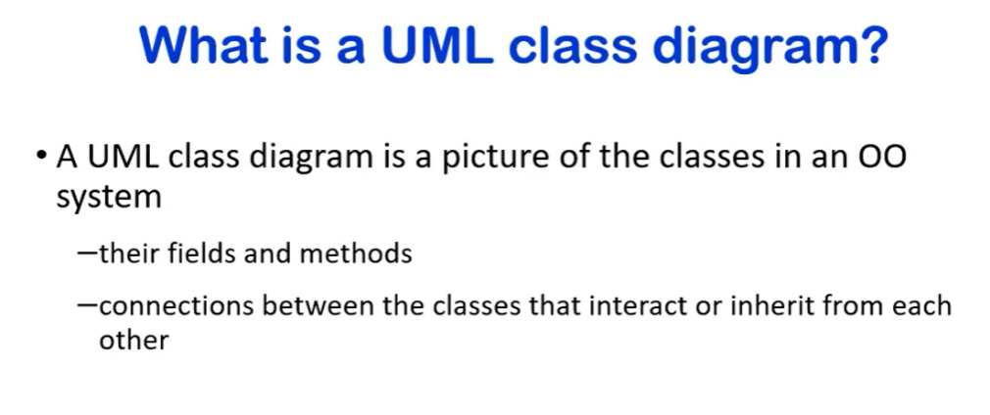

* 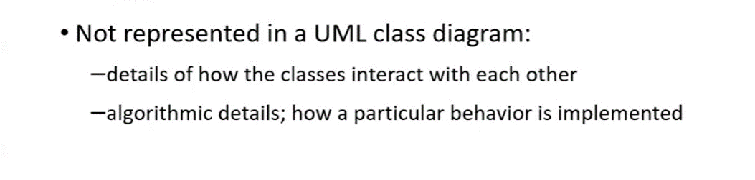
  + shows who interacts with who
  + does not show how
* 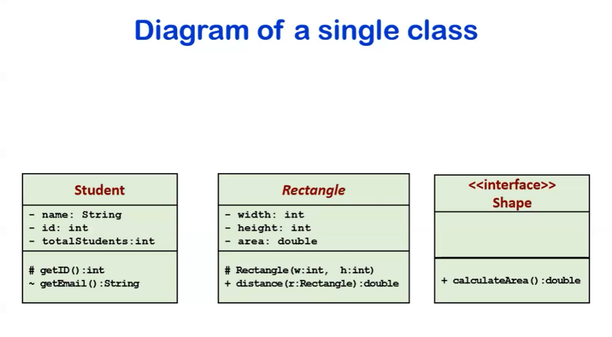
  + name of class on top
  + member name of variables in middle
  + name of methods at the bottom
    - difference between an abstract class and an interface
      * interface has only methods. none of them are implemented
        + extends or includes
      * abstract at least one not implemented
        + extends only
* 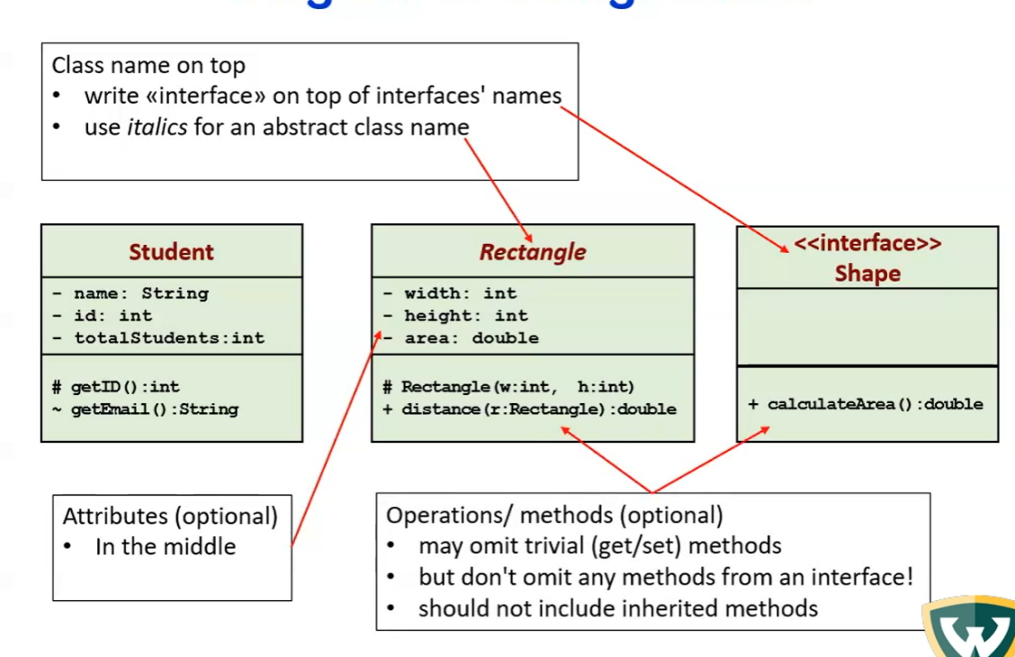

* 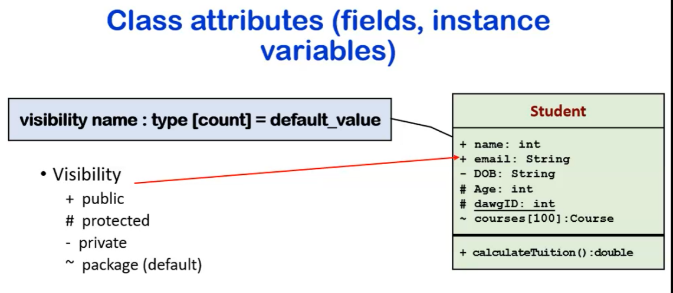
  + underlined variable is static

|  |  |  |
| --- | --- | --- |
| static vs non-static? | static | * + - * + shared between all objects         + does not belong to a particular object         + belongs to class         + access with class name not object name |
|  | non-static | * + - * + belongs to the object         + each object has separate copy         + instance only has one copy |

* 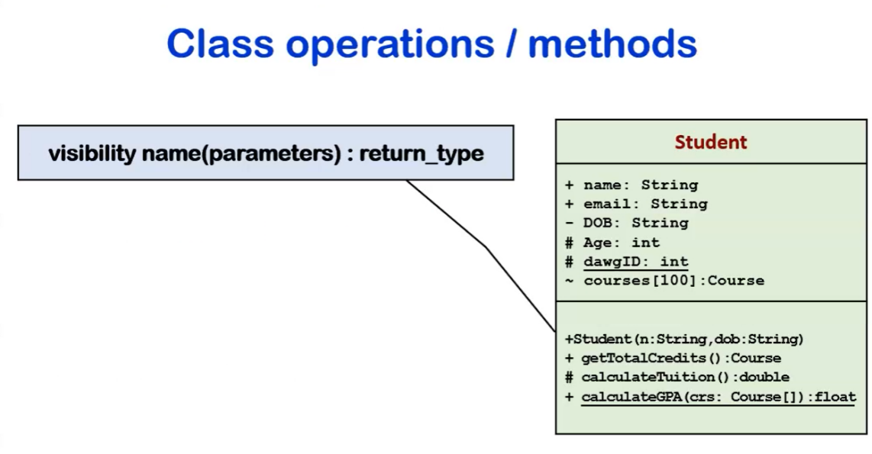

* 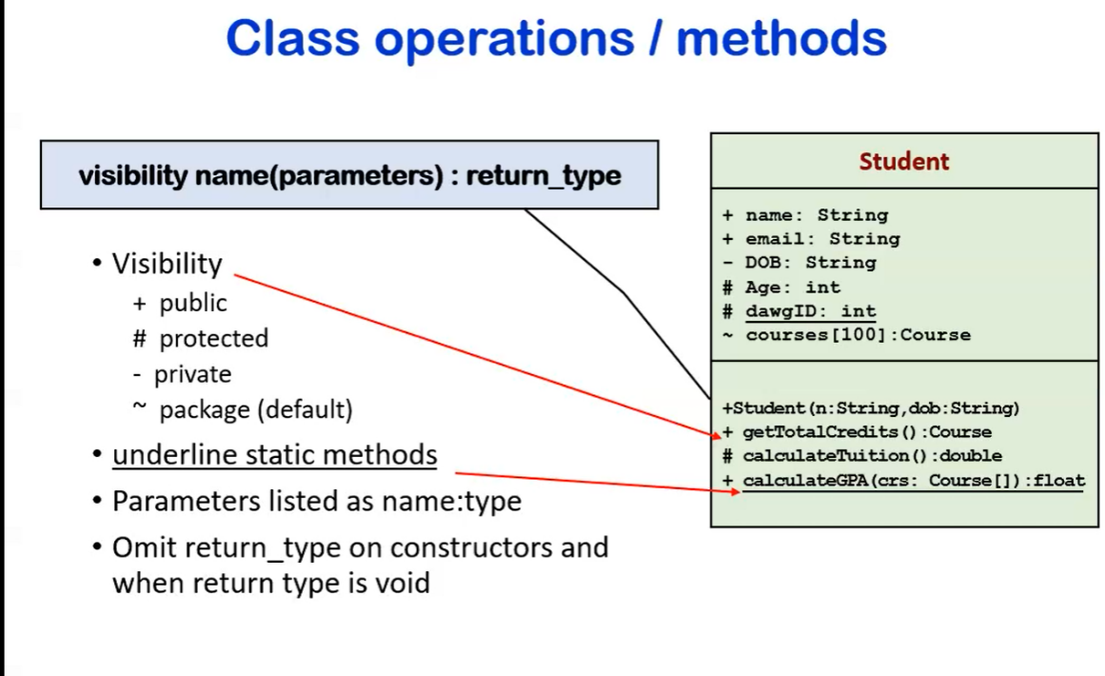

* 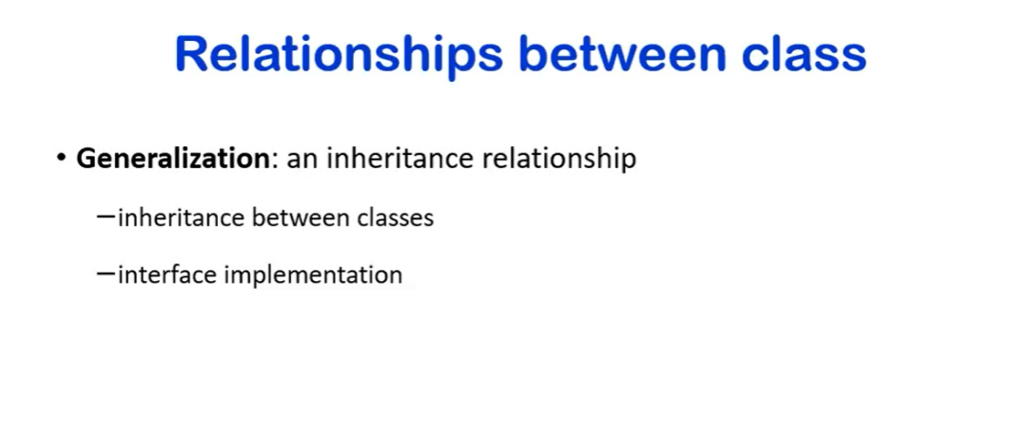
  + how do we denote between them
    - 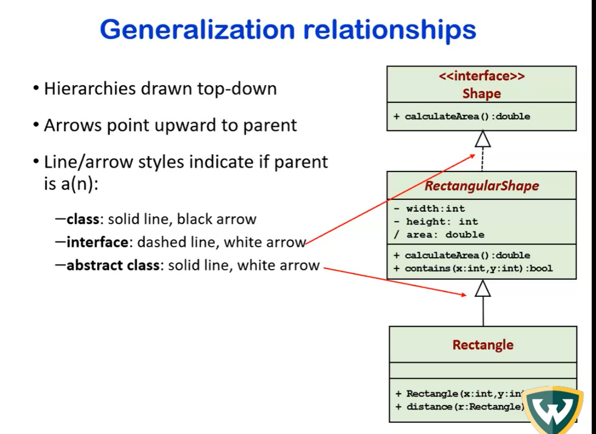

* 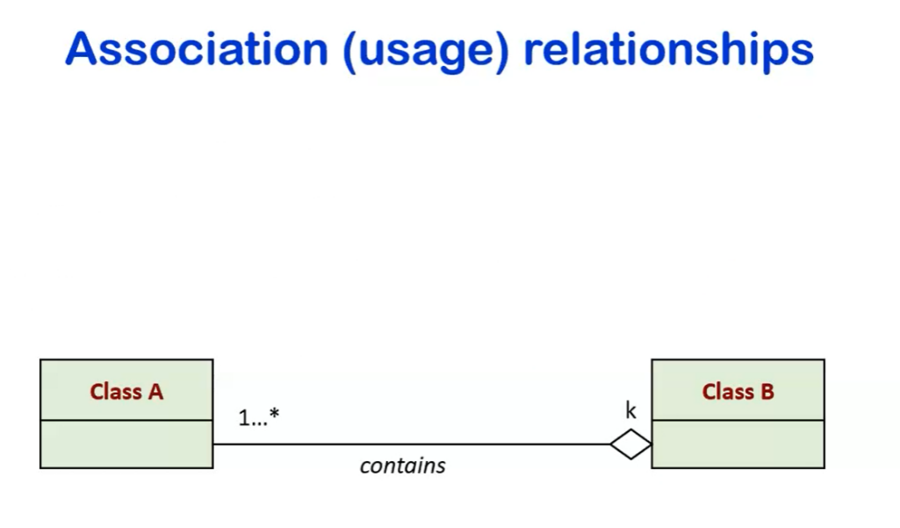

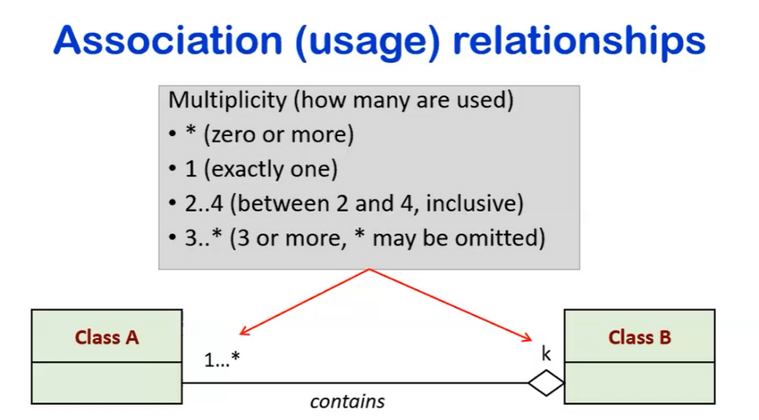

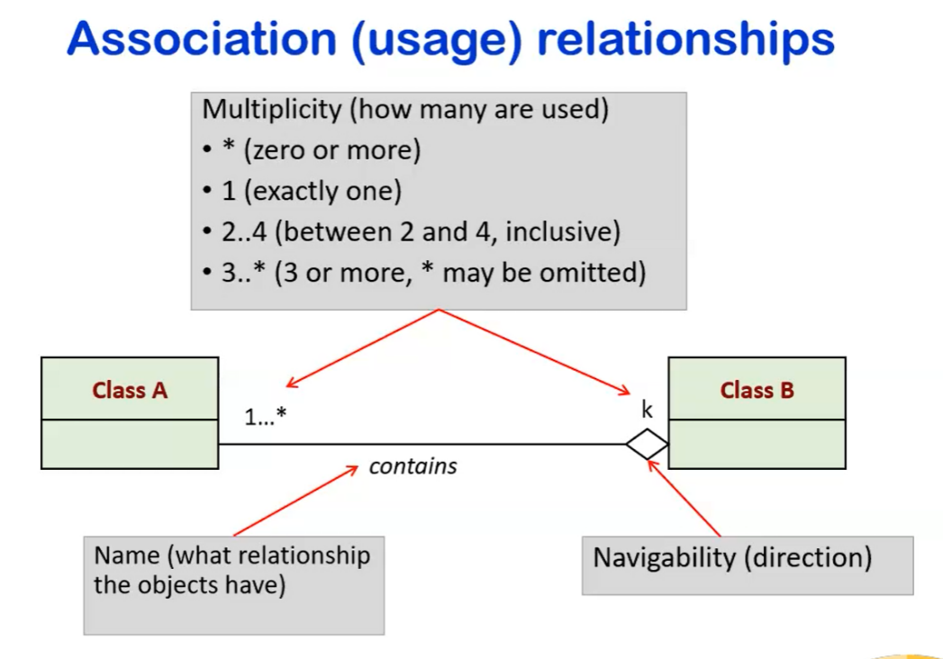

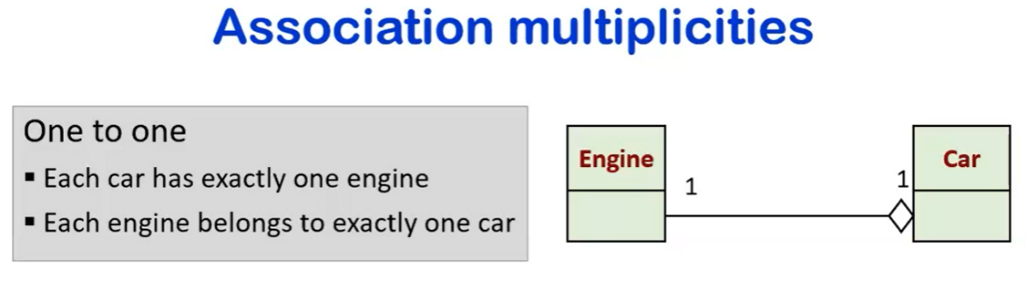

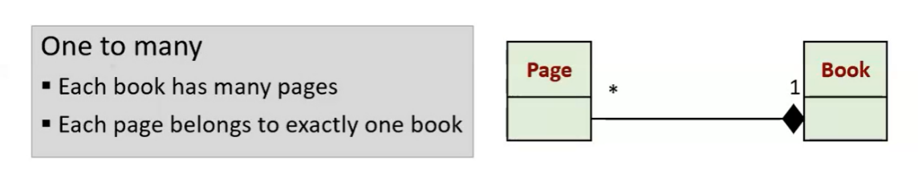

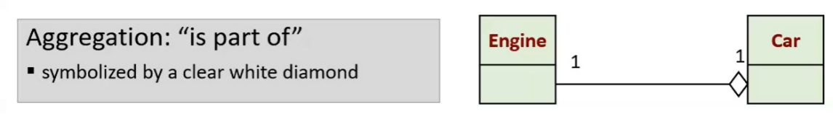

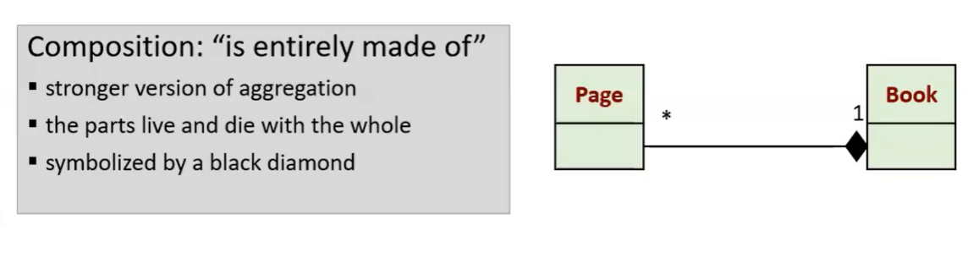

book is actually an object with an array of pages

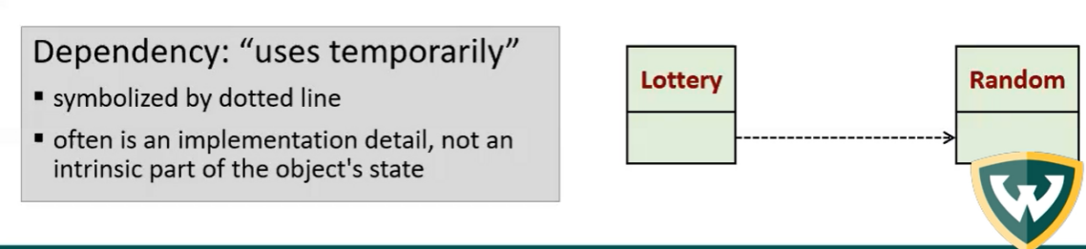

* 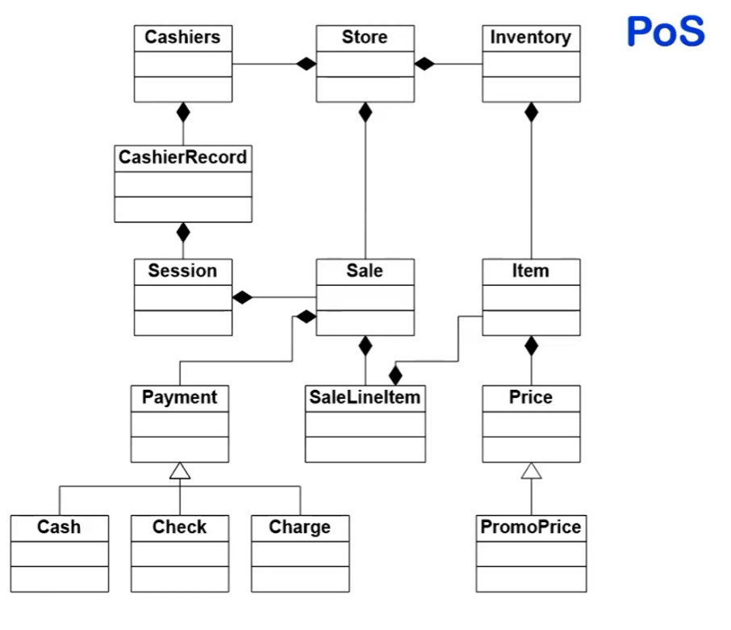
  + point of sale system
    - what are the different entities?
    - what are their relationships?
      * all payment classes
        + open arrow means abstract
      * price and promo price
        + price goes to item is a stronger composition
  + for software developers to see what they need or if anything needs to be added
* 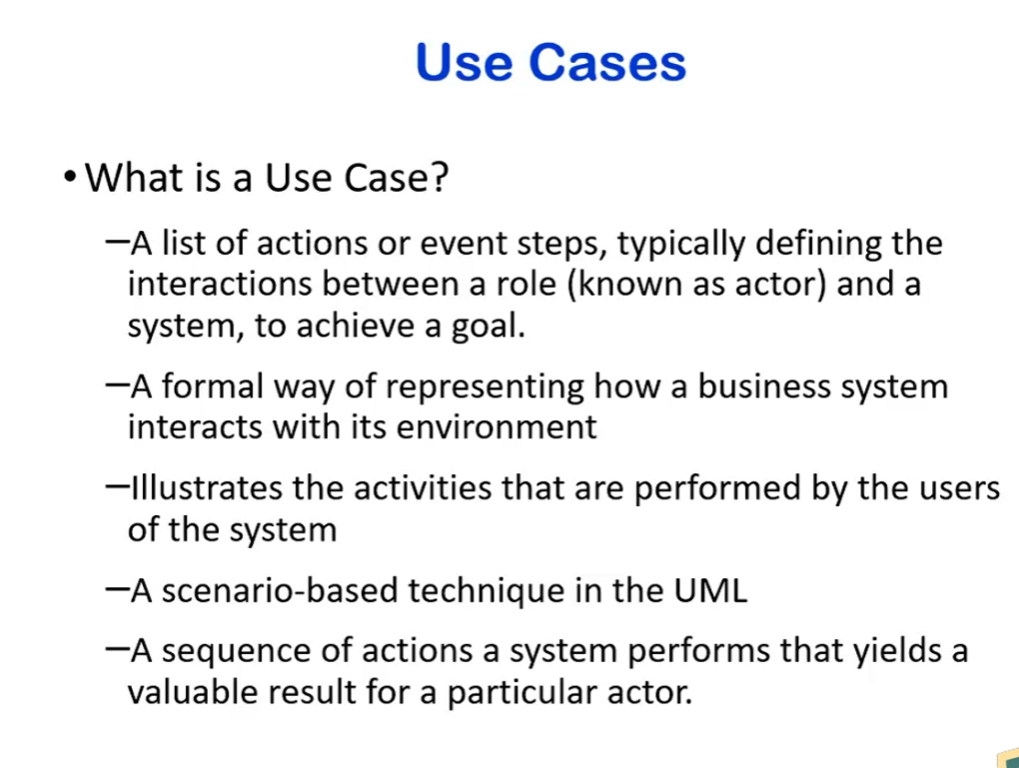
  + not the same as use case diagram
  + talks about special or particular features
  + need to know how this software works
    - what are the conditions
  + a very descriptive detailed list of actions defining the interaction between a rold and a system to achieve a role
  + 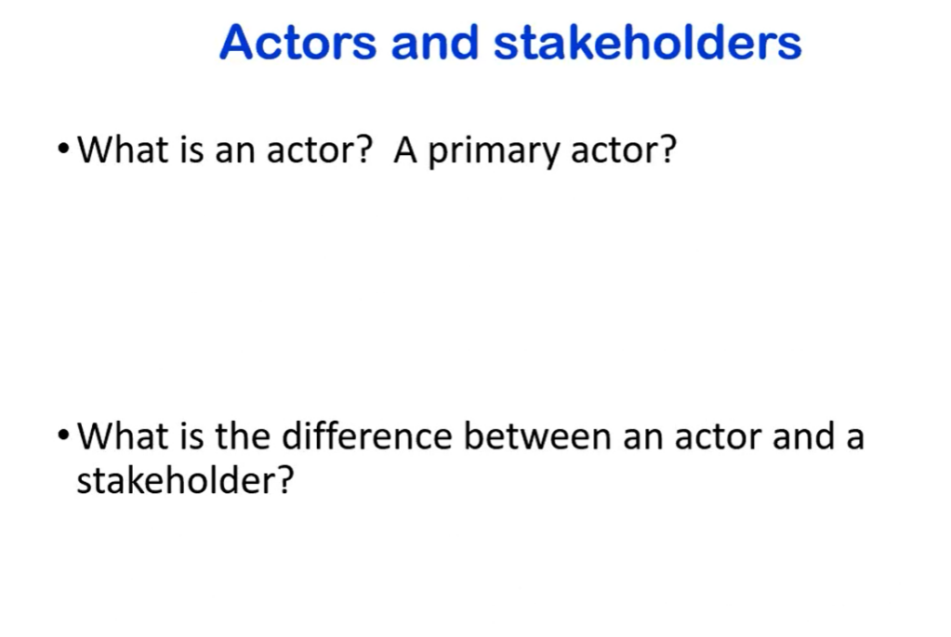
    - to write a use case identify actor/primary actor
      * use case can have more than ine
      * 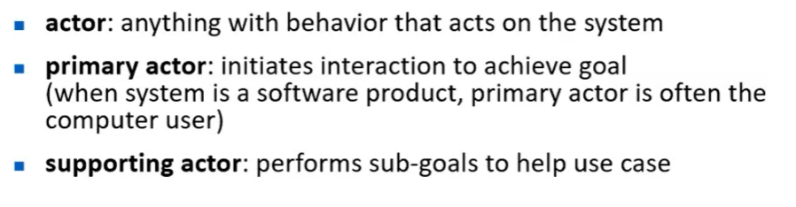

* 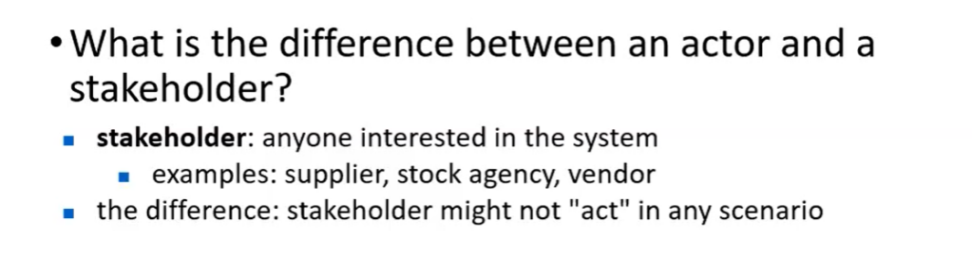
  + stakeholder remains passive
  + actor acts
* 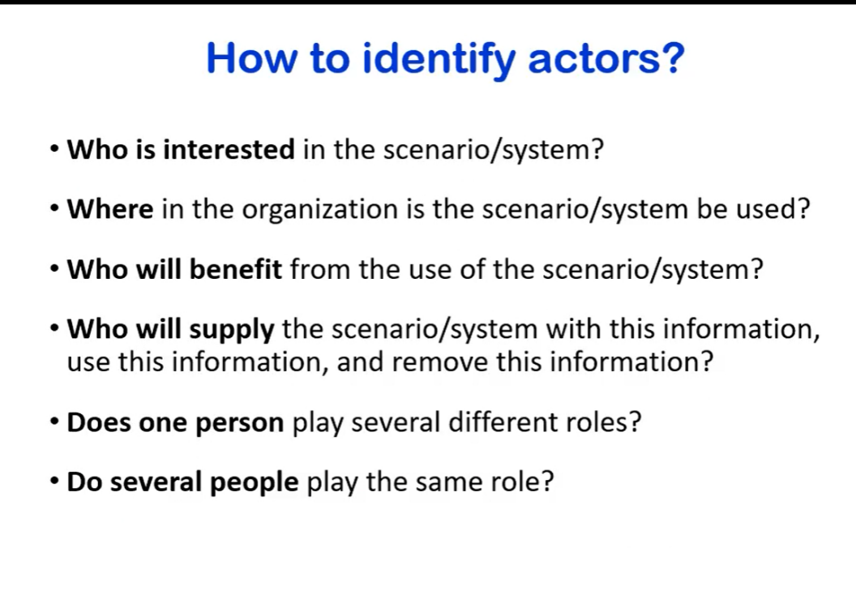

* 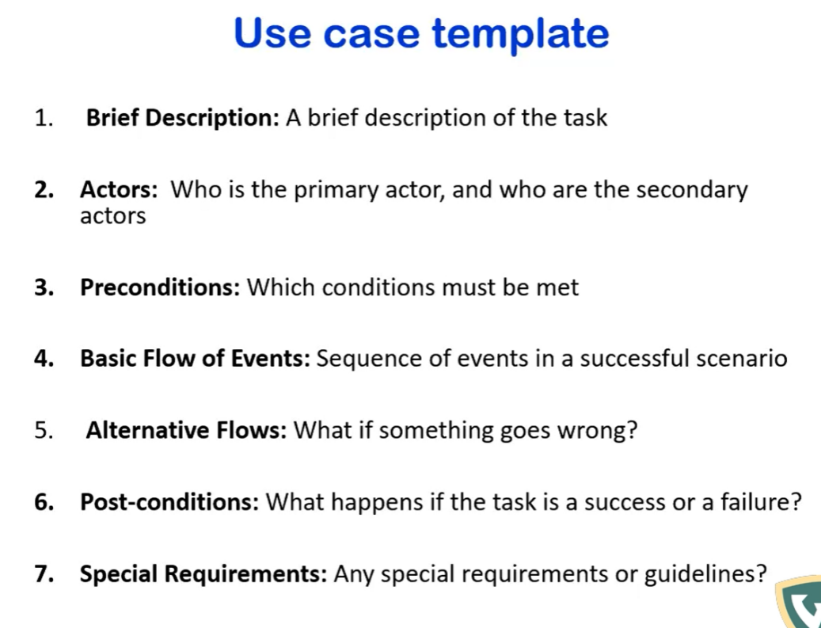

* 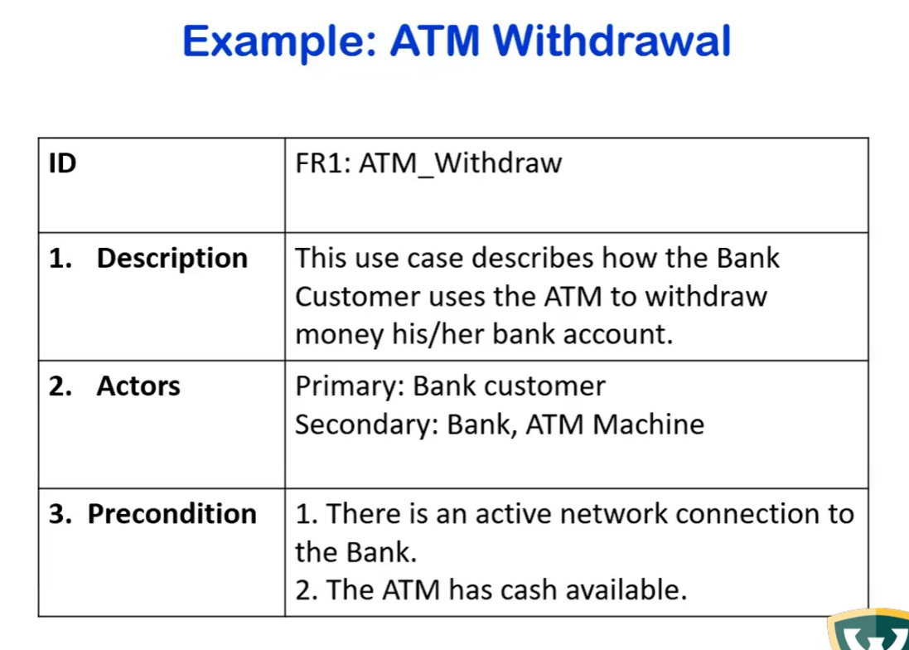

* 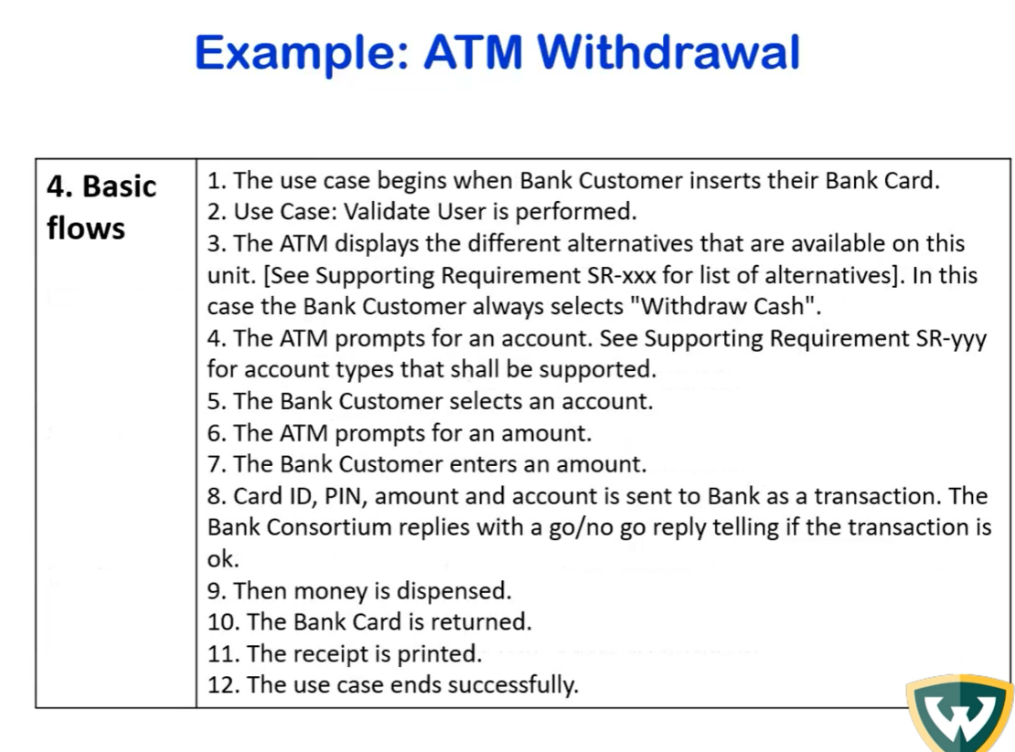
  + write exactly how system should operate
    - success case
* 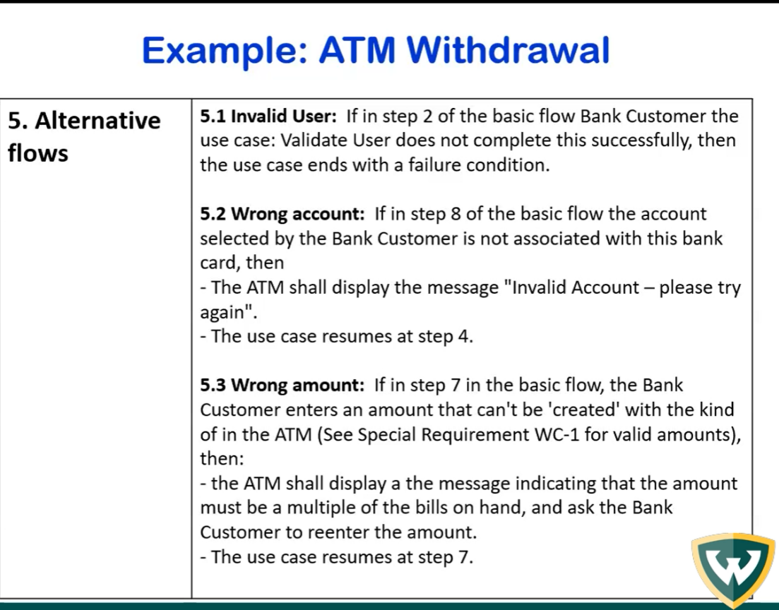
  + how system handles if something goes wrong
* 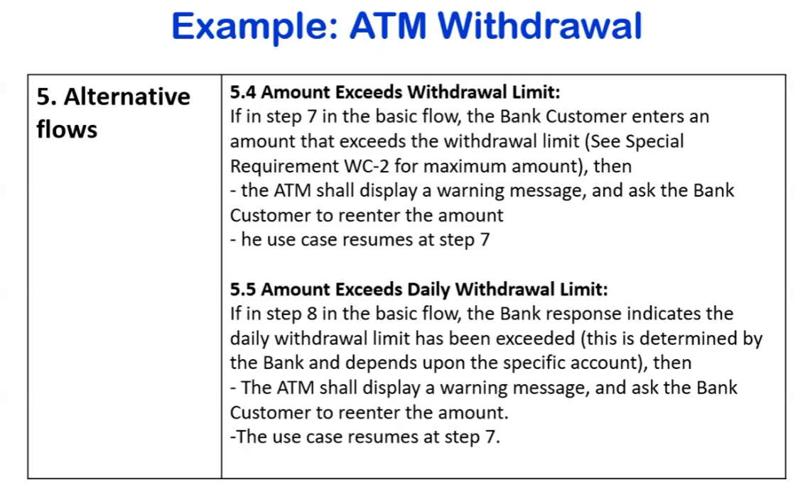

describe how system will handle failure case

* 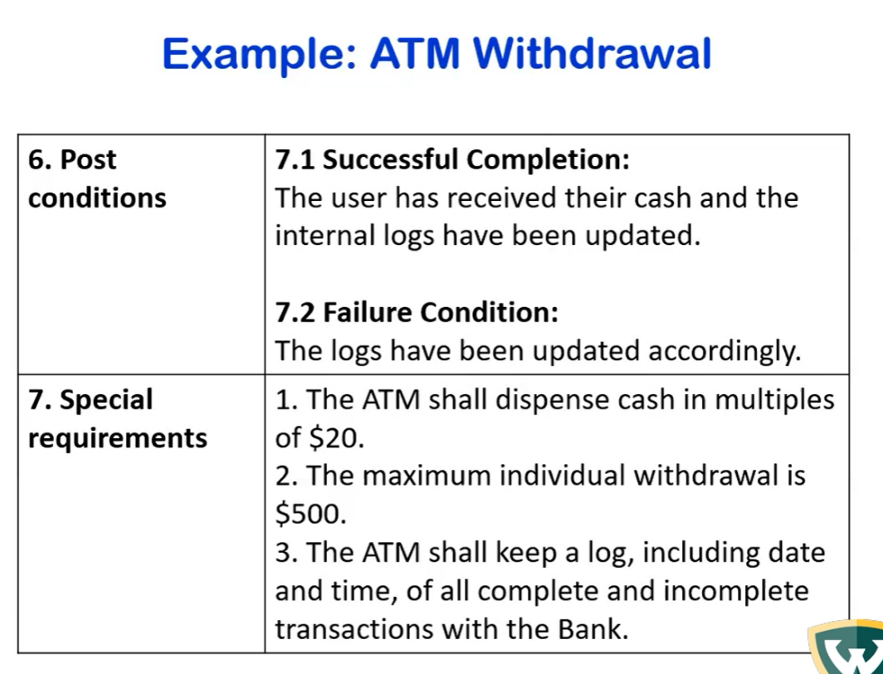
  + post conditions
    - always update successful and failure logs